UNIT I QUIZ 1
Computer Networks
Computer network is a set of devices (often referred to as nodes) connected by communication links. A node can be a computer, printer, or any other device capable of sending and/or receiving data generated by other nodes on the network. A link can be a cable, air, optical fiber, or any medium which can transport a signal carrying information.
Computer Network can be referred as Data Communication or Data Network.The word Data refers to Information.
Data Communications are the exchange of data between two devices via some form of transmission medium such as a wire cable. For data communications to occur, the communicating devices must be part of a communication system made up of a combination of hardware (physical equipment) and software (programs).
The effectiveness of a data communications system depends on four fundamental characteristics:
- Delivery The system must deliver data to the correct destination. Data must be received by the intended device or user and only by that device or user.
- Accuracy The system must deliver the data accurately. Data should not be altered. If the data is altered in transmission and left uncorrected are unusable.
- Timeliness The system must deliver data in a timely manner. Data delivered late are
useless. In the case of video and audio, timely delivery means delivering data as they are produced, in the same order that they are produced and without significant delay. This kind of delivery is called real-time transmission.
- Jitter It refers to the variation in the packet arrival time. Jitter is the uneven delay in the delivery of audio or video packets.
Example: Let us assume that video packets are sent every 3ms. If some of the packets
arrive with 3ms delay and others with 4ms delay, an uneven quality in the video is the result.

COMPONENTS
A data communications system has five components:

Message
The message is the information (data) to be communicated. Popular forms of information include text, numbers, pictures, audio, and video.

Sender
The sender is the device that sends the data message. It can be a computer, workstation, telephone handset, video camera, and so on.

Receiver.
The receiver is the device that receives the message. It can be a computer, workstation, telephone handset, television, and so on.

Transmission medium
The transmission medium is the physical path by which a message travels from sender to receiver. Some examples of transmission media include twisted-pair wire, coaxial cable, fiber-optic cable, and radio waves.

Protocol
A protocol is a set of rules that govern data communications. It represents an agreement between the communicating devices. Without a protocol, two devices may be connected but not communicating, just as a person speaking French cannot be understood by a person who speaks only Japanese.

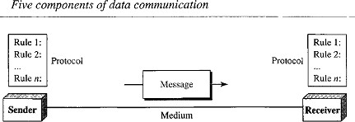
Note: The term TELECOMMUNICATION includes telephony, telegraphy, and television, means communication at a distance (tele is Greek for "far").
DIRECTION OF DATA FLOW
Communication between two devices can be simplex, half-duplex, or full-duplex.
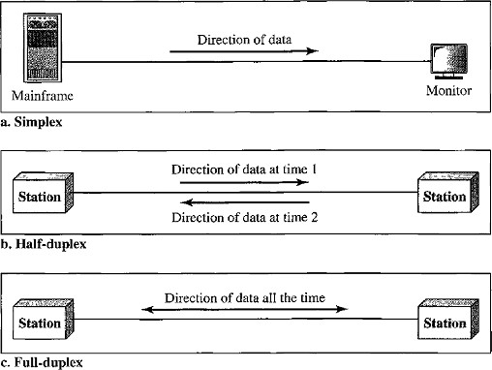

Simplex
- In simplex mode, the communication is unidirectional (i.e. one direction only).
- Only one of the two devices on a link can transmit; the other can only receive.
- The simplex mode can use the entire capacity of the channel to send data in one direction.
- Examples - Keyboards and Monitors, the keyboard can only introduce input, the monitor can only accept output.

Half-Duplex
- In half-duplex mode, each station can both transmit and receive, but not at the same time. When one device is sending, the other can only receive, and vice versa.
- In a half-duplex transmission, the entire capacity of a channel is taken over by whichever of the two devices is transmitting at the time.
- The half-duplex mode is used, where there is no need for communication in both directions at the same time. The entire capacity of the channel can be utilized for each direction.
- Examples - Walkie-talkies and CB (citizens band) radios are both half-duplex systems.

Full-Duplex
- In full-duplex mode (or duplex), both stations can transmit and receive simultaneously.
- In full-duplex mode signals going in one direction share the capacity of the link: with signals going in the other direction
- This sharing can occur in two ways: Either the link must contain two physically separate transmission paths, one for sending and the other for receiving, or the capacity of channel is divided between signals traveling in both directions.
- The full-duplex mode is used when communication in both directions is required all the time. The capacity of the channel must be divided between the two directions.
- Example - Telephone network. Two people talk and listen at the same time.
NETWORKS
A Network is a set of devices (also called as nodes) connected by communication links. (or) A Network is two or more devices connected through links.
A Node can be a computer, printer, or any other device capable of sending and/or receiving data generated by other nodes on the network.
A Link is a communications pathway that transfers data from one device to another.

Type of Connection
Two devices must be connected in some way to the same link at the same time for occurring of communication. There are two possible types of connections:
- Point-to-Point Connection
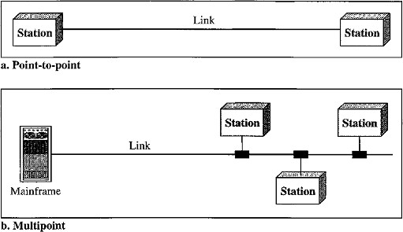
- Multipoint Connection

Point-to-Point Connection
- A Point-to-Point connection provides a dedicated link between two devices.
- The entire capacity of the link is reserved for transmission between those two devices.
- Point-to-Point connections use an actual length of wire or cable to connect the two ends and microwave or satellite links.
- Example: When you change television channels by infrared remote control, you are establishing a point-to-point connection between the remote control and the television's control system.

Multipoint (or) Multi-drop Connection
- A multipoint connection is more than two specific devices share a single link.
- In a multipoint environment, the capacity of the channel is shared, either spatially or temporally.
- If several devices can use the link simultaneously, it is a spatially shared connection. If users must take turns, it is a timeshared connection.
NETWORK TOPOLOGIES
The term physical topology refers to the way in which a network is connected physically. Two or more devices connect to a link. Two or more links form a topology.
There are four basic topologies are present:
  - Bus
  - Ring
  - Star
  - Mesh

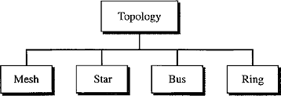

Bus Topology
- A bus topology is multipoint connection, one long cable acts as a backbone to link all the devices in a network. Here the cable is called the bus.
- Bus topology was the one of the first topologies used in the design of early local area networks.
- Nodes are connected to the bus cable by drop lines and taps.
- A drop line is a connection running between the device and the main cable.
- A tap is a connector that splices into (attached to) the main cable.
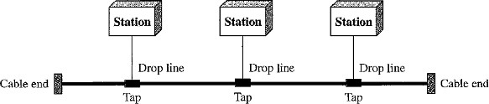
Advantages:
- Installation is easy. Bus Backbone cable can be laid along the most efficient path and then connected to the nodes by drop lines of various lengths.
- A bus uses less cabling than mesh or star topologies.
Disadvantages:
  - All the devices are connected to bus backbone cable, so that if the backbone cable fails the entire system fails.
  - Difficult Reconnection and Fault Isolation. It is difficult to add new devices.
  - There is a limit on the number of taps a bus can support and on the distance between those taps.
  - More heat is generated if the number of taps are more. Heat degrades the quality of signal.

Ring Topology
- In a ring topology, each device has a dedicated point-to-point connection with only the two devices on either side of it.
- A signal is passed along the ring in one direction from device to device, until it reaches its destination.
- Each device in the ring incorporates a repeater. When a device receives a signal intended for another device, its repeater regenerates the bits and passes them along.

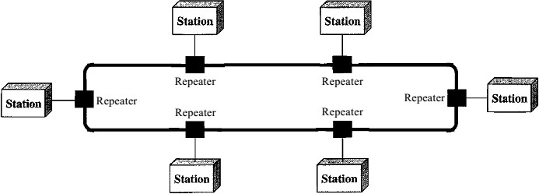
Advantages:
- A ring is relatively easy to install and reconfigure. Each device is linked to only its immediate neighbors (either physically or logically).
- To add or delete a device requires changing only two connections.
- The only constraints are media and traffic considerations (maximum ring length and number of devices).
Disadvantage:
- Unidirectional traffic can be a disadvantage.
- In a simple ring, a break in the ring (such as a disabled station) can disable the entire network.

Star Topology
- In a star topology, each device has a dedicated point-to-point link only to a central controller called a Hub or Switch. The devices are not directly linked to one another.
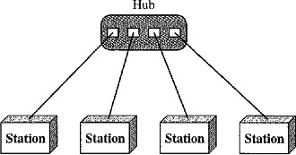
- A star topology does not allow direct traffic between devices. The controller acts as an exchange: If one device wants to send data to another, it sends the data to the controller, and the controller transfers the data to the other connected device.
Advantages:
- A star topology is less expensive than a mesh topology. In a star, each device needs only one link and one I/O port to connect it to any number of others. This factor also makes it easy to install and reconfigure
- Less cabling is required than mesh topology.
- Star topology is robust, If one link fails, only that link is affected. All other links remain active.
Disadvantages:
1. If hub fails entire processing will be stopped working. Uses:
- It is used in High-speed LAN’s often use a star topology with a central hub.

Mesh Topology
- In a mesh topology, every device has a Dedicated Point-to-Point link to every other device. (i.e.) for each node there is a link to all other nodes.
- The term Dedicated means that the link carries traffic only between the two devices it connects.
Advantages:
  - A mesh topology is robust. If one link becomes unusable, it does not affect the entire system.
  - The use of dedicated links guarantees that each connection can carry its own data load, thus eliminating the traffic problems that can occur when links must be shared by multiple devices.
  - Privacy or Security. When every message travels along a dedicated line, only the intended recipient sees it. Physical boundaries prevent other users from gaining access to messages.
  - Point-to-Point links make Fault Identification and Fault Isolation easy.

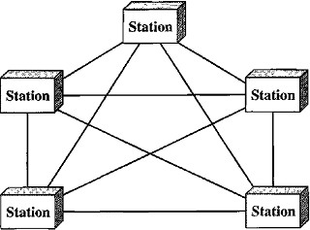
5.
Disadvantages:
- High Cost: Every device must be connected to every other device then there is a high amount of cabling and huge number of I/O ports required, this will make installa tion and reconnection are difficult.
- The hardware required to connect each link (I/O ports and cable) can be prohibitively expensive.
- More hardware (i.e. cables) and space is required
Example: Telephone offices and Police stations.
Connection of telephone regional offices in which each regional office needs to be connected to every other regional office.

Hybrid Topology
It is a combination of two or more topologies for example star topology with each branch connecting several stations in a bus topology

CATEGORIES OF NETWORKS
There are 3 categories of networks depend on its size:
- Local Area Networks (LAN)
- Metropolitan Area Networks (MAN)
- Wide Area Networks (WAN)

Local Area Networks
- A Local Area Network (LAN) provides short-distance transmission of data over small geographic areas that may comprise a single office, building, or campus.
- Size: LAN size is limited to a few kilometers.
- Speed: Early LANs had data rates in the 4 to 16 megabits per second (Mbps) range but now speeds are increased to 100 or 1000 Mbps.
- LANs are designed to allow resources to be shared between personal computers or workstations.
- The resources to be shared can include hardware (e.g., a printer), software (e.g., an application program), or data.
- A local area network (LAN) is usually privately owned.
- LAN will use only one type of transmission medium.
- The most common LAN topologies are bus, ring, and star.

Wide Area Network
A Wide Area Network (WAN) provides long-distance transmission of data, image, audio, and video information over large geographic areas that may comprise a country, a continent, or even the whole world.
The switched WAN connects the end systems, which usually comprise a router (inter- networking connecting device) that connects to another LAN or WAN.
The point-to-point WAN is often used to provide Internet access. A line leased from a telephone provider that connects a home computer or a s mall LAN to an Internet service provider (lSP).

Metropolitan Area Networks
A Metropolitan Area Network (MAN) is a network with a size between a LAN and a WAN. It normally covers the area inside a town or a city.
It is designed for customers who need a high-speed connectivity to the Internet, and have endpoints spread over a city or part of city.
Example of a MAN is the part of the telephone company network that can provide a high- speed DSL line to the customer.

